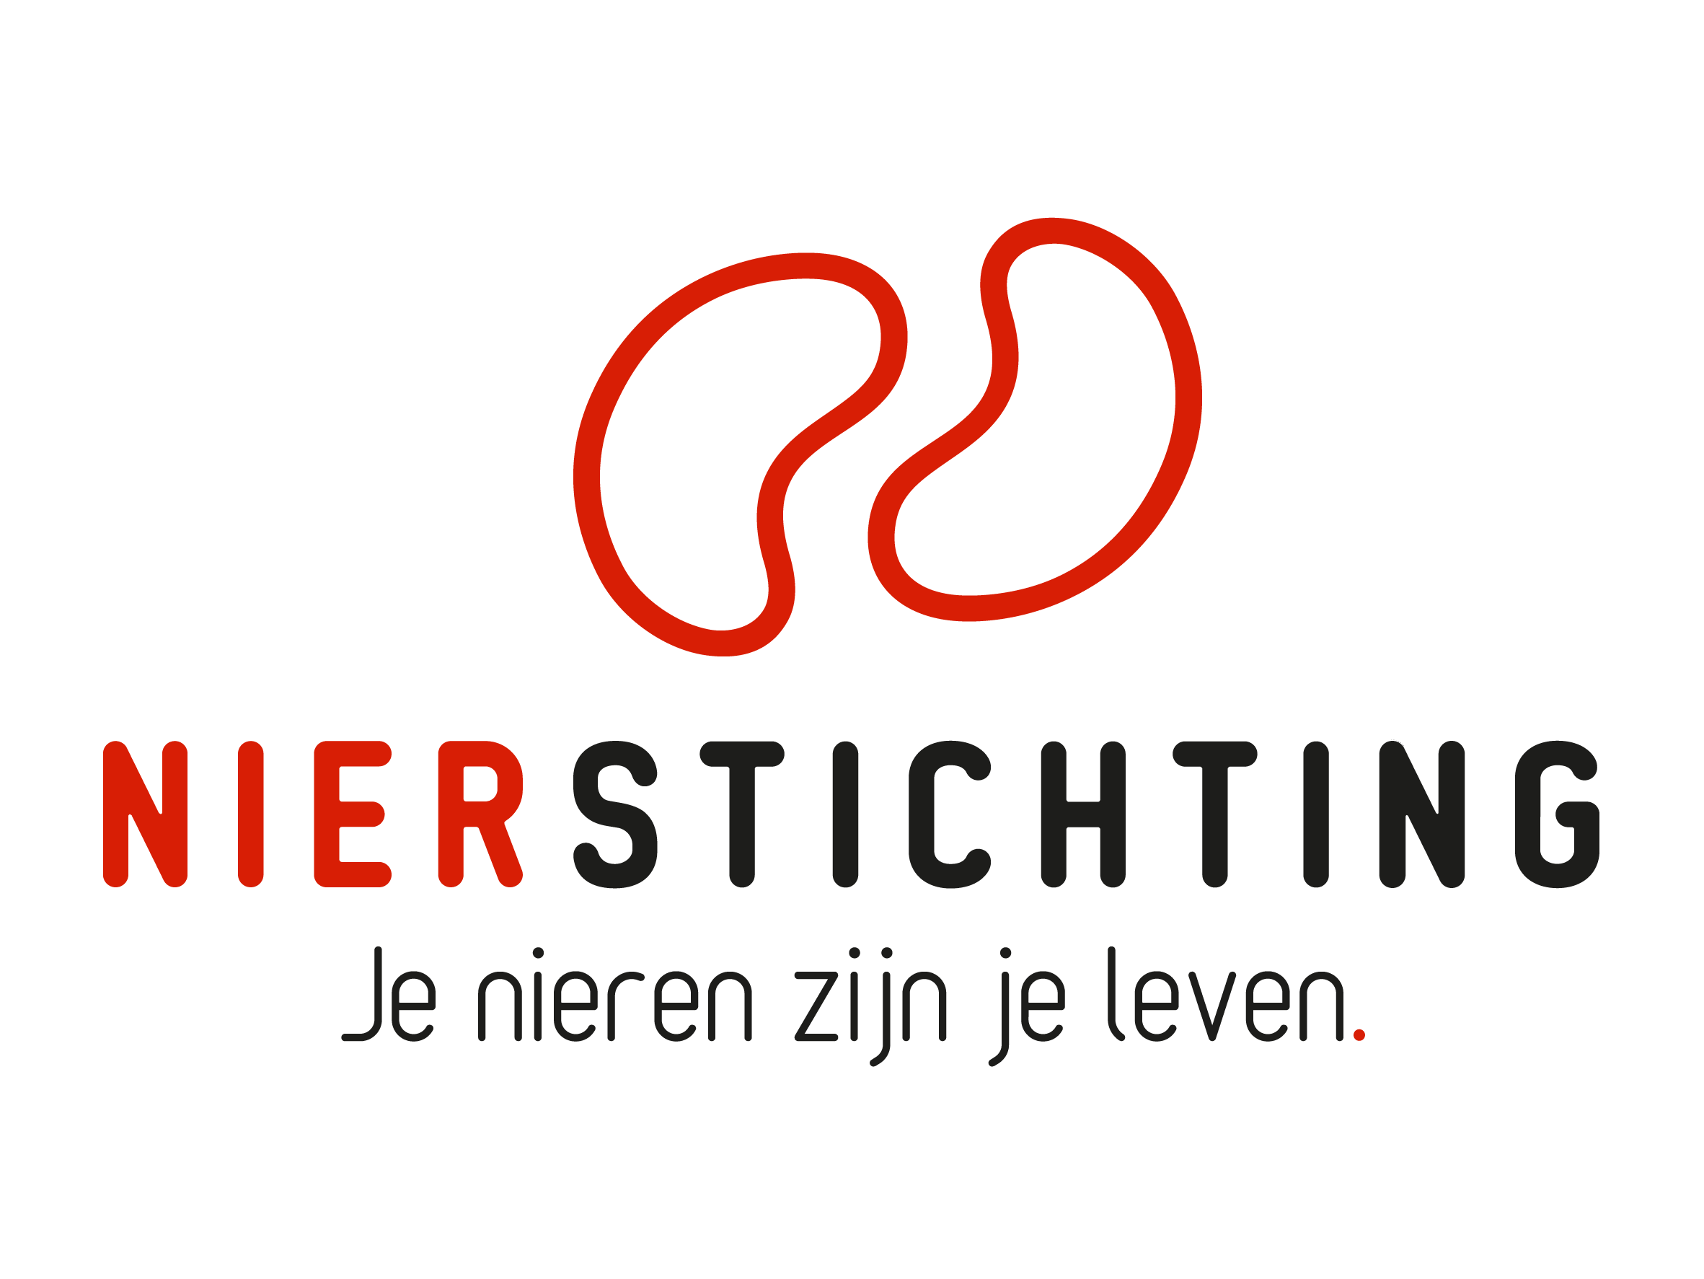
Dutch Kidney Foundation
Review form Final Report
Consortium Grant
30 December 2019

Nierstichting / Dutch Kidney Foundation
+31 (0)35 697 8015
research@nierstichting.nl

Instructions for completing and submitting this form
- Your personal details are registered in our grant management system called MIDAS. You can modify your personal details or add information via the system. This review form will be send to the applicant in anonymised form and therefore has no space for your personal details.
- Please convert the completed form into a searchable PDF file. Upload the PDF file to your digital submission form in MIDAS.

1. Project
Project code
Project title
Acronym (optional)
Applicant name

2. Organisation

2.1 Assess the consortium management, performance of the principal investigator and coordination. Evaluate the overall organisation.

2.2 Please give scores (X) based on your own expertise.
 | poor | fair | average | good | excellent
Management
Principal Investigator
Coordination
Overall

3. Cohesion

3.1 Assess the consortium cohesion: synergy, collaboration and the translational perspective. Evaluate the overall strength.

3.2 Please give scores (X) based on your own expertise.
 | poor | fair | average | good | excellent
Synergy & additive value
Collaboration
Translational perspective
Overall

4. Output

4.1 Assess the output of the consortium, execution with respect to the original time frame and publications. Evaluate the overall output.

4.2 Please give scores (X) based on your own expertise.

 | poor | fair | average | good | excellent
Results & deliverables
Execution according to plan
Delivered as promised
Publications: number
Publications: quality
Overall

5. Broad Impact

5.1 Assess the final impact of the consortium for patients, risk groups and/or the general public as well as the impact from a scientific, clinical/preventive and societal perspective. Assess the impact on the renal field in the Netherlands and abroad as well as the expected future impact. Evaluate overall impact.

5.2 Please give scores (X) based on your own expertise.

 | poor | fair | average | good | excellent
Patients, risk groups and/or the general public
Scientific
Clinical/preventive
Societal
Renal field in the Netherlands and abroad
Future impact
Overall

6. Follow-up performance and opportunities

6.1 Assess the follow-up. Evaluate overall follow-up.

6.2 Please give scores (X) based on your own expertise.
 | poor | fair | average | good | excellent
Dissemination
Implementation
Research and development
Funding
International collaboration
Start-up and business
Overall

7. Conclusions

7.1 Final assessment of the consortium. What is your recommendation?

7.2 Please give an overall score (X) based on your own expertise.
 | poor | fair | average | good | excellent
Overall

